Abdul Samad Shaikh

NED DSAI B5

Python

(Assignment 1)

**Various methods of writing very first (Hello world) program in python**

**Method1: By Using Command Prompt**

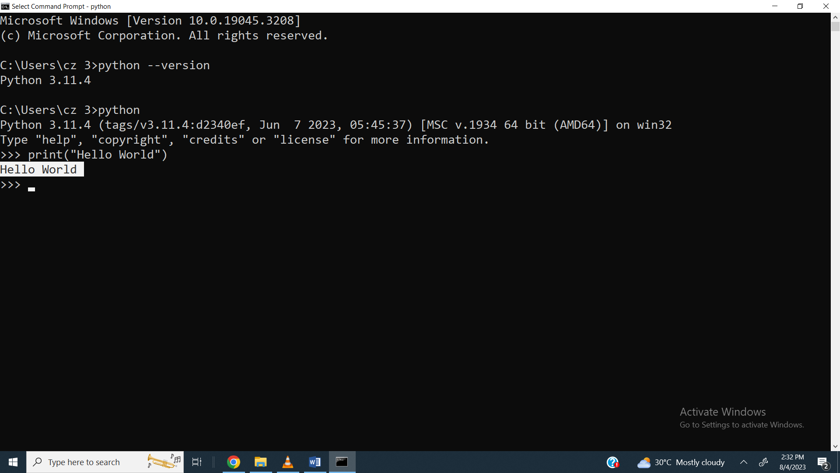

Method 2: ByUsing Jupyter Lab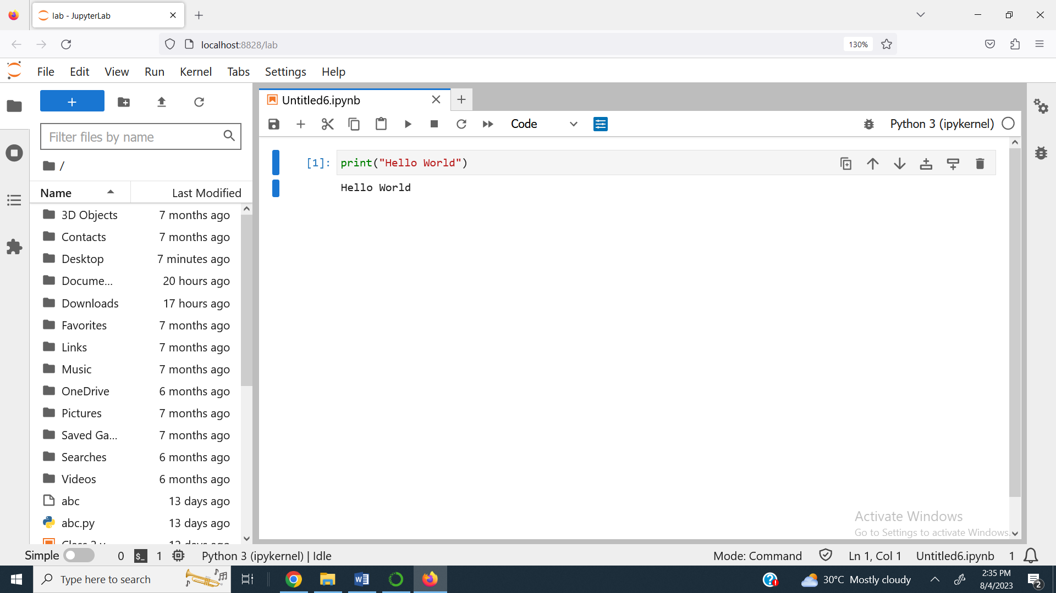

Method 3: By Using Jupyter Notebook

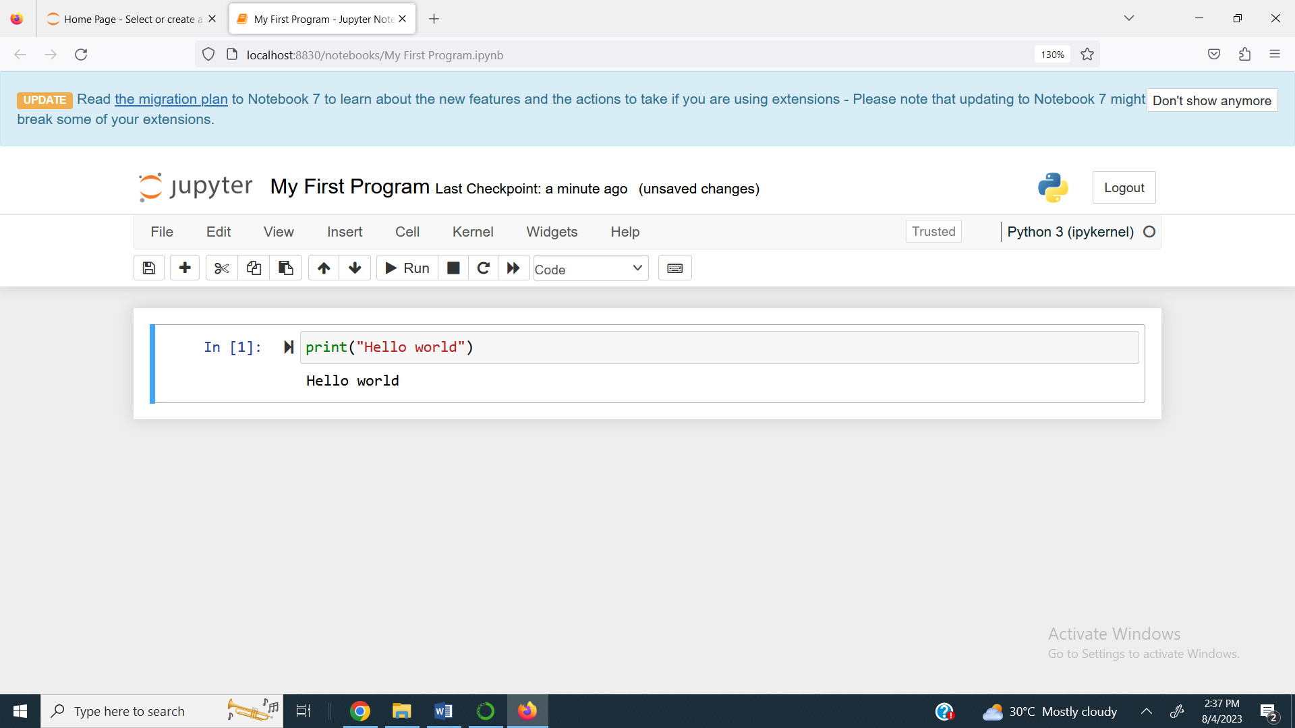

Method 4: By Using Visual Studio Code

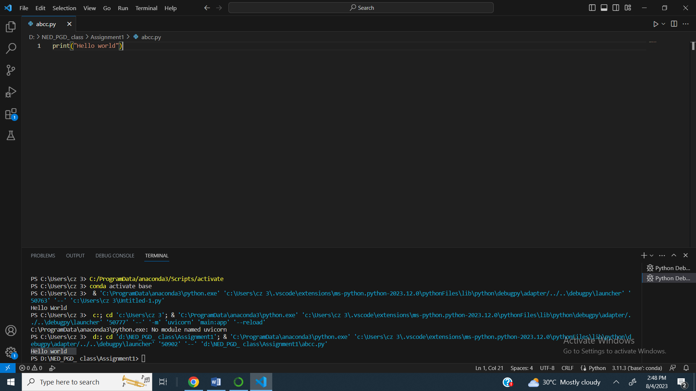

Method 5: By Using Google Colab

